

|  |  |
| --- | --- |
| **ASSIGNMENT** | |
| **Course Code** | 19CSC211A |
| **Course Name** | Formal Languages and Automata Theory |
| **Programme** | B-Tech |
| **Department** | Computer Science and Engineering |
| **Faculty** | Faculty of Engineering and Technology |

|  |  |
| --- | --- |
| **Name of the Student** | Tanishq R Porwar |
| **Reg. No** | 18ETCS002131 |
| **Semester/Year** | 4th semester /2nd year |
| **Course Leader/s** | Prakash P |

|  |  |  |  |  |  |  |  |  |
| --- | --- | --- | --- | --- | --- | --- | --- | --- |
| **Declaration Sheet** | | | | | | | | |
| Student Name | Tanishq R Porwar | | | | | | | |
| Reg. No | 18ETCS002131 | | | | | | | |
| Programme | B. Tech | | | | | Semester/Year | 4th semester /2nd year | |
| Course Code | CSC211A | | | | | | | |
| Course Title | FORMAL LANGUAGES AND AUTOMATA THEORY | | | | | | | |
| Course Date |  | | to | |  | | | |
| Course Leader | Prakash P | | | | | | | |
| **Declaration**  The assignment submitted herewith is a result of my own investigations and that I have conformed to the guidelines against plagiarism as laid out in the Student Handbook. All sections of the text and results, which have been obtained from other sources, are fully referenced. I understand that cheating and plagiarism constitute a breach of University regulations and will be dealt with accordingly. | | | | | | | | |
| Signature of the Student | |  | | | | | Date | May 20, 2020 |
| Submission date stamp  (by Examination & Assessment Section) | |  | | | | | | |
| Signature of the Course Leader and date | | | | Signature of the Reviewer and date | | | | |
|  | | | |  | | | | |

# **Contents**

____________________________________________________________________________

**Declaration Sheet** 2

**Contents** 3

**Question No. 1** 3

# **Question No. 1**

## Solution to Question No. 1:

### Introduction

A context-free grammar (CFG) consists of a set of productions that you use to replace a variable by a string of variables and terminals. The language of a grammar is the set of strings it generates. A language is context-free if there is a CFG for it. Context-free grammars (CFGs) are used to describe context-free languages. A context-free grammar is a set of recursive rules used to generate patterns of strings. A context-free grammar can describe all regular languages and more, but they cannot describe all possible languages. Based on the characteristics of CFG containing recursive rules. The idea to reach the goal is to add a memory device to a FSA. A FSA with a memory device is called a pushdown automaton (PDA). PDA is an automaton with finite states and the memory can be unbounded. With the application of a PDA, it will be able to recognize a CFG. Pushdown Automata is a finite automaton with extra memory called stack which helps Pushdown automata to recognize Context Free Languages. A Pushdown Automata (PDA) can be defined as in a given state, PDA will read input symbol and stack symbol (top of the stack) and move to a new state and change the symbol of stack.

Now in the introduction to the problem defined. Online transaction platforms are vulnerable to frauds in this case the fraud is detected when amount to be sent or received is above the threshold accessed. So to provide security we ask for two kinds of user pin one is login pin to login into the platform and another for the transaction to happen after request of send or receive which is called the transaction pin so if there is any mistake happened there then the online platform directly aborts are moves back. There is one more important place where fraud happening with the details of the previous transaction where more money than the threshold accessed is requested to send or receive then the automata is designed to ask a security question which is provided with a valid answer. So the user should give a valid answer for his request to be proceed or for the transaction to happen. If not the automaton is designed in a manner where it aborts and transaction has been cancelled which is considered as a fraud happening.

The specification for the automaton it starts with the login where the login pin is verified followed by transaction which selects a bank after which request for send or receive money is done. If the amount is less than threshold limit then the app asks for transaction pin if its right transaction happens or abort. If the amount is more than threshold limit then the platform asks a security question for a valid answer. So if the answer is valid complete transaction or abort. These are the ways in which online transaction platforms are secured from fraud happening in these areas.

Design and validations

Specification of Context-Free Grammar(CFG) for the above problem, design of Push Down Automata(PDA) that recognizes sentences from the CFG

|  |  |
| --- | --- |
| **Non-Terminals (Variables)** | **Terminals** |
| $$S-Start$$ | $$c-Correct Pin$$ |
| $$L-Login$$ | $$w-Wrong Pin$$ |
| $$B-Bank$$ | $$f-Fail/ Abort$$ |
| $$T-Types of Transation$$ | $$a-Send Money$$ |
| $$A-Choose Amount$$ | $$b-Receive Money$$ |
| $$P-Transaction Pin$$ | $$l-Amount less than threshold$$ |
| $$Q-Security Question$$ | $$g-Amount greater than threshold$$ |
| $$F-Transation Finished$$ | $$x-Answer to Security Question$$ |
| $$X-Abort$$ | $$p-Correct Transaction Pin$$ |
|  | $$s-SBI Bank$$ |
|  | $$i-ICICI Bank$$ |

Table 1: List of Terminals and Non-Terminals

Let G be the context free grammar for the problem

$$G=(V,Ʃ,P,S)$$

Where, $V$ is the set of Variables, $Ʃ$ is the set of terminals, $P$ is the Production rule, $S$ is the start symbol

$$V= \left\{S,L,B,T,A,P,Q,F,X\right\}$$

$$Ʃ= \left\{c,w,f,a,b,l,g,x,p,s,i\right\}$$

Where the productions are,

$S→L$

$L→cT$

$T→aB | bB$

$B→iA | sA$

$A→lP | gQ$

$Q→xP$

$P→p$

Let the equivalent PDA be **P**,

$$P=(Q, Ʃ, S,δ, qo, F,I)$$

Where, $Q$ is the set of states, $Ʃ$ is the set of input alphabet, $S$ is the set of stack symbols, $δ$ is the transition function, $qo$ is the initial state, $F$ is the set of accepting symbols, $I$ is the initial stack top symbol

Where

,

,z0

And  −



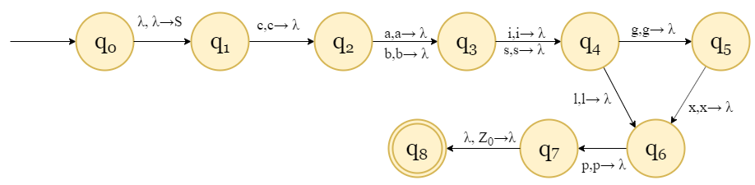

Validation using stack:

Input string: caigxp

* Initially the stack has z0, to check if we are at the end of the stack, by reading $λ$ from the input string, we push start symbol **S** to the top of the stack [ $δ(q,λ,λ)=(q,S)$]
* **S** is replaced by **L** [$δ(q,λ,S)=(q,L)$]
* **L** is replaced by **cT** [$δ\left(q,λ,L\right)=\left(q,cT\right)$], now to top of the stack is **c** which is a terminal, so we read from the input string
* As the input is **c**, we pop **c** from the stack. If the input wasn’t **c** then we would abort

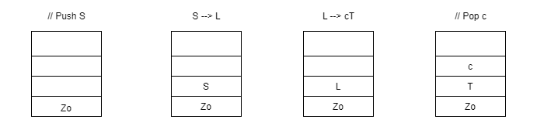

* Now, T is at the stop of the stack
* **T** is replaced **aB | bB ,** top of the stack is **a** or **b** so the we read the input
* As the input is a, we pop a from the stack

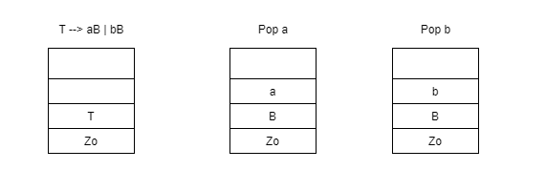

* Now the top of the stack is B
* B is replaced by **iA | sA ,** so we read the input
* As the input is **i** , we pop **i** from the stack

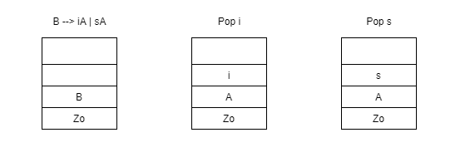

* Now A is at the top of the stack
* A is replaced by lP | gQ, we read from the input
* As the input is g, we pop g from the stack

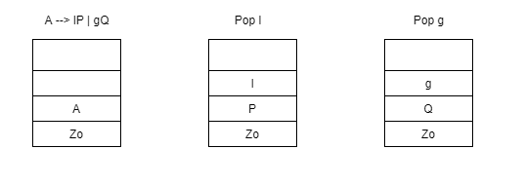

* Now Q is at the top of the stack
* Q is replaced by xP, we read from the input
* As the input is x, we pop x from the stack

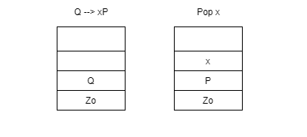

* Now P is at the top of the stack
* P is replaced by p, we read from the input
* As the input is p, we pop p from the stack
* z0 is at the top of the stack, we have reached the end of the stack
* zo is popped from the stack, the stack is empty Transaction is complete

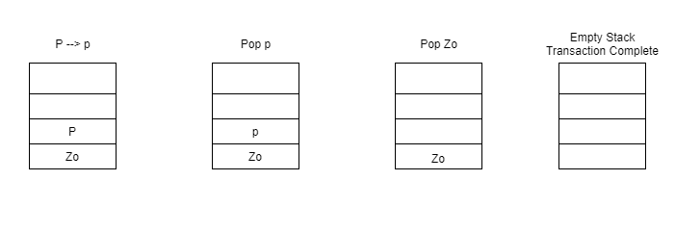

### Conclusion

In conclusion, this is a Npda meaning A non-deterministic pushdown automaton (NPDA), or just pushdown automaton (PDA) is a variation on the idea of a non-deterministic finite automaton (NDFA). Unlike an NDFA, a PDA is associated with a stack (hence the name pushdown). The transition function must also take into account the “state” of the stack. A PDA is non-deterministic if in some state there are several possible transitions. It doesn't matter if that applies to a transition to a final state. From state q0 with Z0 on the stack, on reading a there is one possibility. In the same case there is no alternative on input. So this online transaction software or application is a non-deterministic pushdown automaton the way it is been develop becomes to come to end there have more than one end state. To develop a platform without fraud we use the NPDA in this application for security where it can abort if there is a problem during transaction.